NUTRITION PROGRAM – MOCKUP PROPOSAL

1. **Project Introduction**

Base on researching functions on existing nutrition program which is running on MS-EXCEL, I would like to give you the mockup proposal of Nutrition Program in web application for back-end and front-end including mobile user supports.

BACK-END MODULES:

+ User Management

+ Food & Menu Management

+ System Parameters Setting

FRONT-END MODULES:

+ User Profiles

+ Food & Menus Management

+ Reports

APPS MODULES:

+ User Profiles

+ Food & Menus Management

+ Reports

1. Back-end module introduction
2. What is it?

This is including core functions of whole system. It allows administrational users to setup necessary parameters of the nutrition system. It is included:

+ User Management

+ Food & Menu Management

+ System Parameters Setting

1. Who can access to this module?

+ Administrator

+ Trainer

1. Mockup demo

Login screen: when user login to system, system will redirect to main screen based on each roles

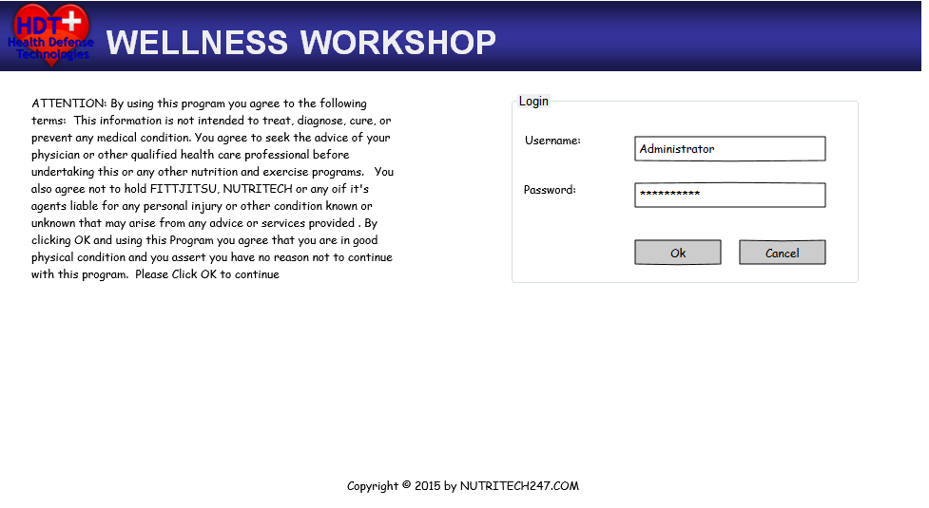

Administrator - Dashboard screen:

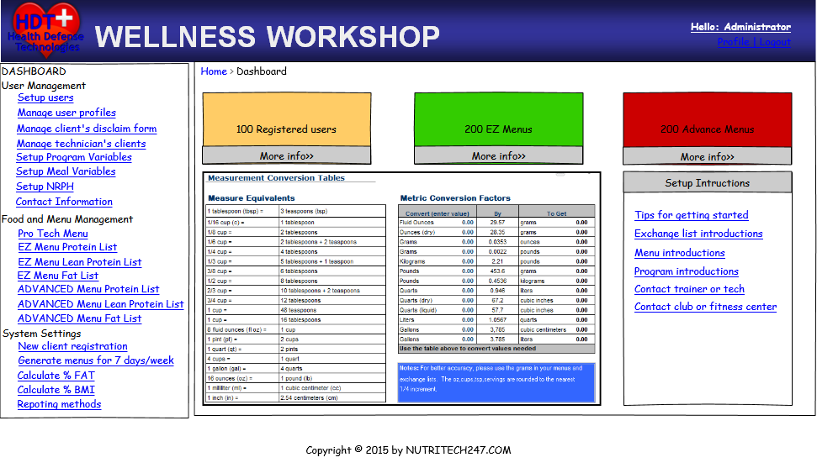

Administrator -Setup User Screen:

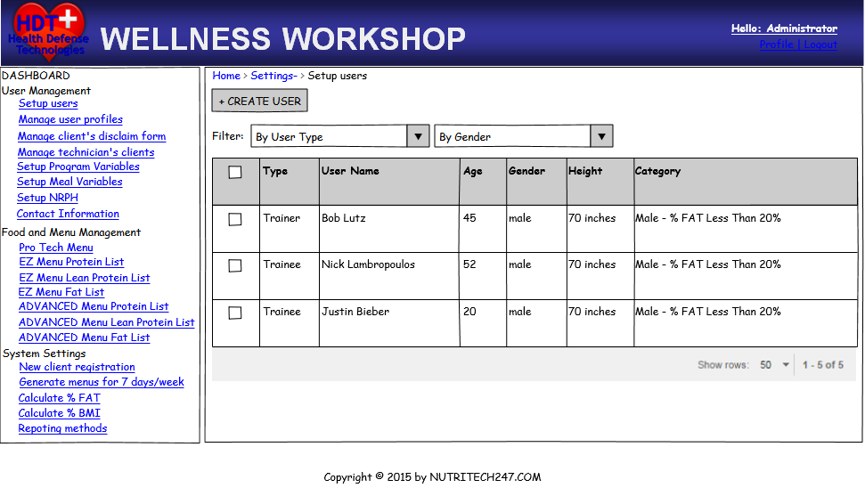

Trainer-Dashboard screen:

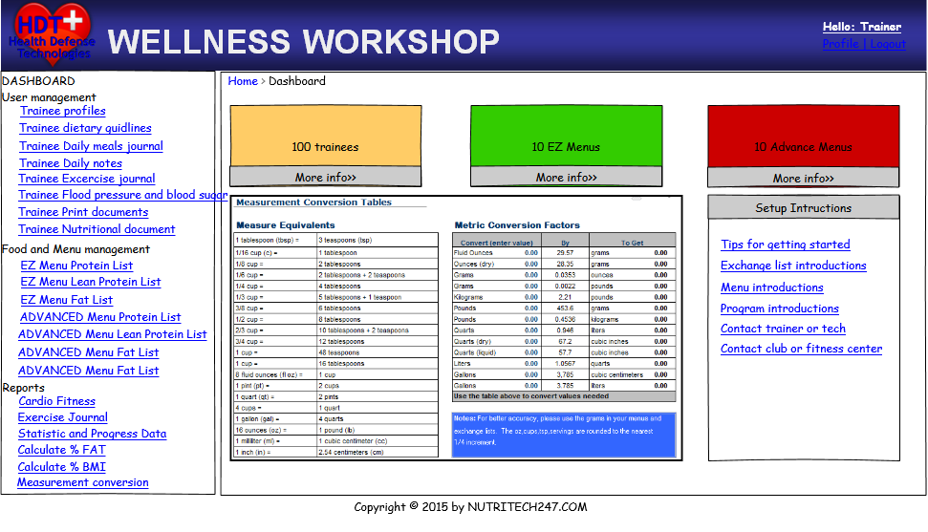

1. Front-end module on App

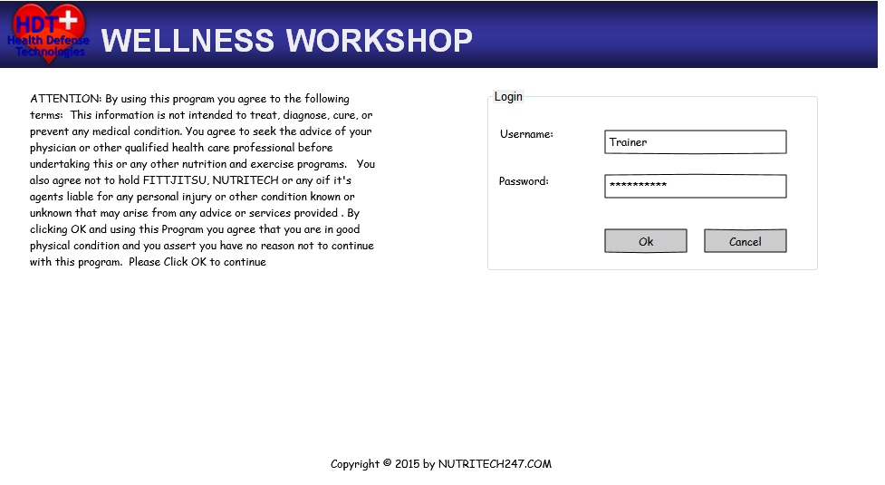

Trainer-Dashboard Screen



Trainer-Dashboard Screen

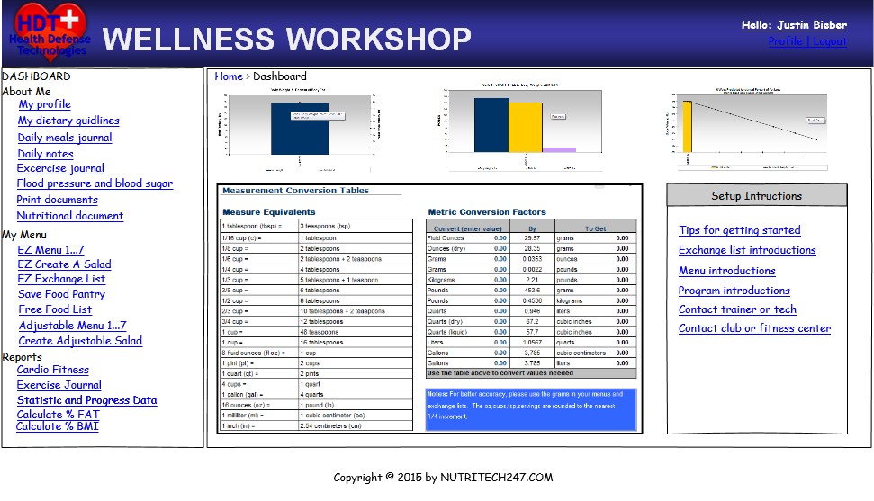

1. Front-end on Apps

Please provide your expectation on mobiles apps which we will support for trainee and trainer(if have).

Please identify process for new trainer and registered trainee.

1. **Technology Requirement**

Apps: Swift/Objective-C wrapper for iOS, Java wrapper for Android

Backend: meal plan logic in Java/JSP and MongoDB RESTFul api from backend to front end

1. **Project Timelines**
2. **Budget Estimation**
3. **Next Steps**